Commits made to GitHub Repository:
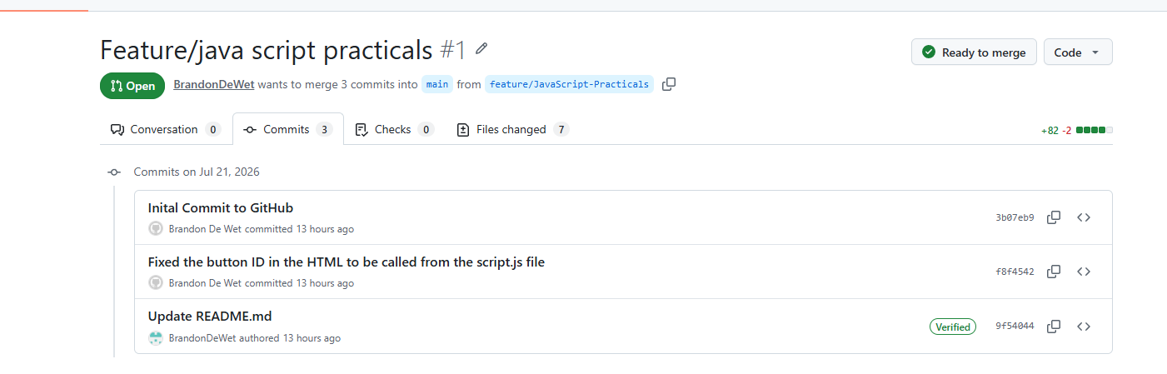
Creating Pull Request on GitHub:
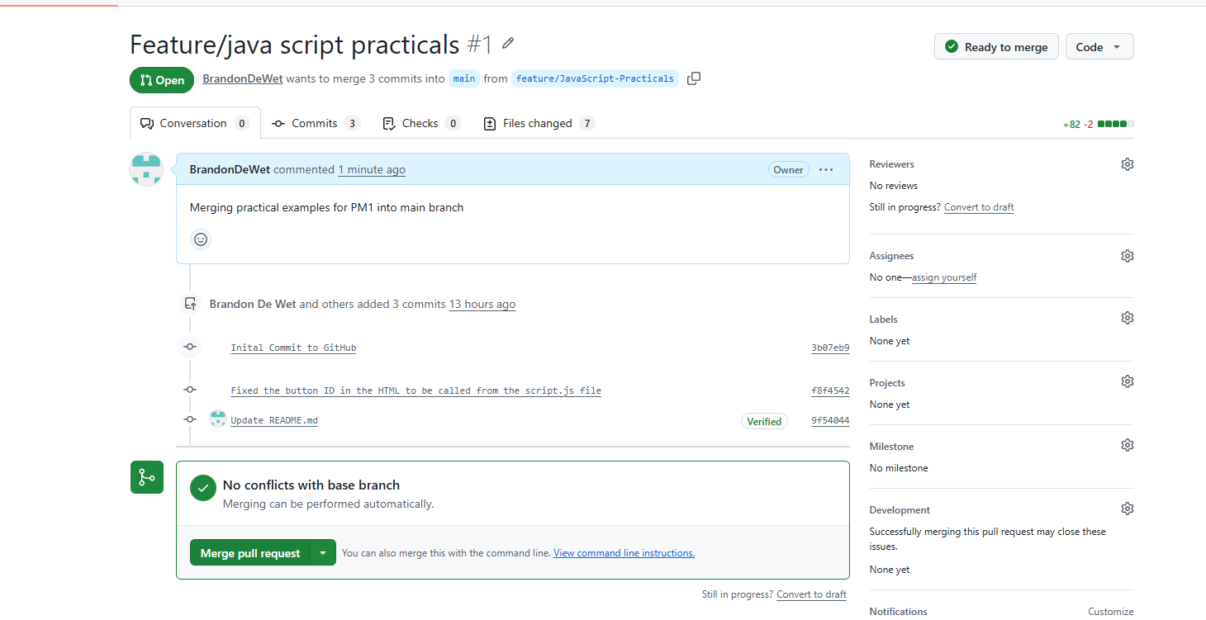
Commits:
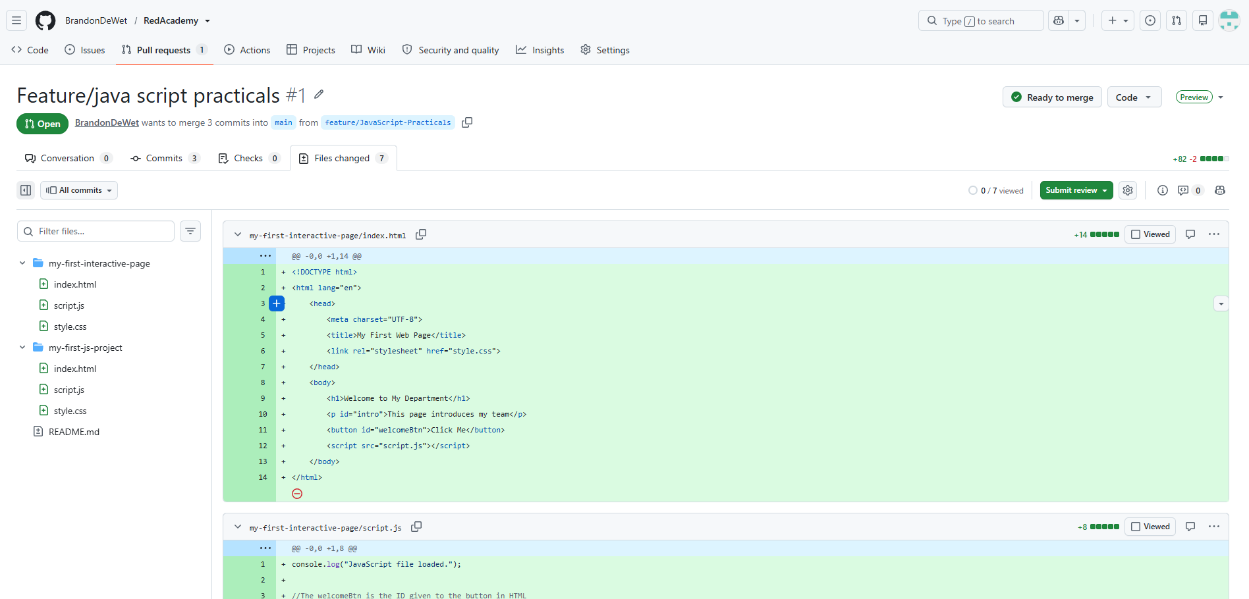
Merged changes to Main Branch: 